UNITED STATES

SECURITIES AND EXCHANGE COMMISSION
Washington, D.C. 20549

SCHEDULE 14A

Proxy Statement Pursuant to Section 14(a) of the
Securities Exchange Act of 1934

(Amendment No. )

Filed by the Registrant ☒

Filed by a Party other than the Registrant ☐

Check the appropriate box:

- Preliminary Proxy Statement

- Confidential, for Use of the Commission Only (as permitted by Rule 14a-6(e)(2))

- Definitive Proxy Statement

- Definitive Additional Materials

- Soliciting Material under §240.14a-12

Erasca, Inc.

(Name of Registrant as Specified In Its Charter)

(Name of Person(s) Filing Proxy Statement, if other than the Registrant)

Payment of Filing Fee (Check all boxes that apply):

- No fee required

- Fee paid previously with preliminary materials

- Fee computed on table in exhibit required by Item 25(b) per Exchange Act Rules 14a-6(i)(1) and 0-11

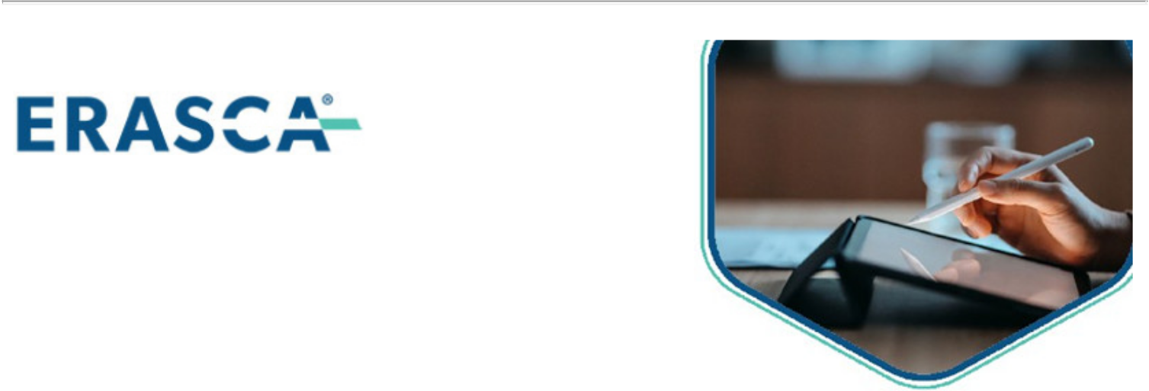
P.O. BOX 8016, CARY, NC 27512-9903



Erasca, Inc.

Annual Meeting of Stockholders

Friday, June 26, 2026 11:30 AM, Pacific Time

Annual Meeting to be held live via the internet - please visit www.proxydocs.com/ERAS for more details

You must register to attend the meeting online and/or participate at www.proxydocs.com/ERAS

For a convenient way to view proxy materials, VOTE, and obtain directions to attend the meeting go to www.proxydocs.com/ERAS

To vote your proxy while visiting this site, you will need the 12 digit control number in the box below.

This communication presents only an overview of the more complete proxy materials that are available to you on the Internet. This is not a ballot. You cannot use this notice to vote your shares. We encourage you to access and review all of the important information contained in the proxy materials before voting.

Under United States Securities and Exchange Commission rules, proxy materials do not have to be delivered in paper. Proxy materials can be distributed by making them available on the internet.

If you want to receive a paper or e-mail copy of the proxy material, you must request one. There is no charge to you for requesting a copy. In order to receive a paper package in time for this year’s meeting, you must make this request on or before June 15, 2026.

SEE REVERSE FOR FULL AGENDA

Meeting Materials: Notice of Meeting and Proxy Statement & Annual Report or Form 10-K

Important Notice Regarding the Availability of Proxy Materials for the Stockholders Meeting To Be Held On June 26, 2026 For Stockholders of record as of April 27, 2026

To order paper materials, use one of the following methods.


Internet:

www.investorelections.com/ERAS



Call:

1-866-648-8133



Email:

paper@investorelections.com

- If requesting material by e-mail, please send a blank e-mail with the 12 digit control number (located below) in the subject line. No other requests, instructions OR other inquiries should be included with your e-mail requesting material.
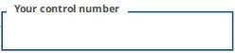

Have the 12 digit control number located in the box above available when you access the website and follow the instructions.

Copyright © 2026 BetaNXT, Inc. or its affiliates. All Rights Reserved

Erasca, Inc. Annual Meeting of Stockholders


THE BOARD OF DIRECTORS RECOMMENDS A VOTE:

- FOR ON PROPOSALS 1 AND 2

PROPOSAL

1. To elect three directors to serve as Class II directors for a three-year term expiring at the 2029 Annual Meeting of Stockholders and until their respective successors shall have been duly elected and qualified

1.01 Alexander W. Casdin

1.02 Julie Hambleton, M.D.

1.03 Michael D. Varney, Ph.D.

- To ratify the appointment of KPMG LLP as our indpendent registered public accounting firm for the fiscal year ending December 31, 2026

- To transact such other business as may properly come before the Annual Meeting or any continuation, postponement or adjournment of the Annual Meeting

